Contents
1. Prepare the sort code file 1
2. Upload new bank sort codes 7
3. Check upload data in PeopleXD Payroll Dashboard 9

Prepare the sort code file

- An updated monthly Global Payments file is made avaialble by the 23rd of each calendar month. Click on the below URL to navigate to the LexisNexis Risk Solutions shared file service:

https://adfd.accuity.com
- On the login screen, enter username “UniOfOxfordGB01P” and password “Uni0xfor&6Bridge”.

For connectivity issues please email support at: productsupportteam@lexisnexisrisk.com including your username and method of access

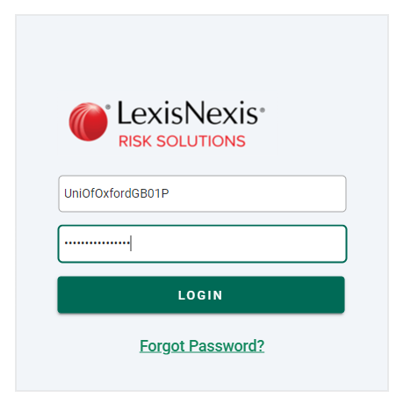
- From the Files tab click on the ‘GPF_ERP_ASCII’ folder.

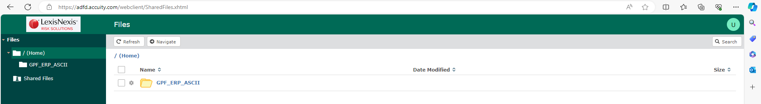

- Then click on the grf_erp.txt file to download and save this at P:\PROJECTS\HRIS Programme\12. Support\Reference Data\Bank Sort Codes

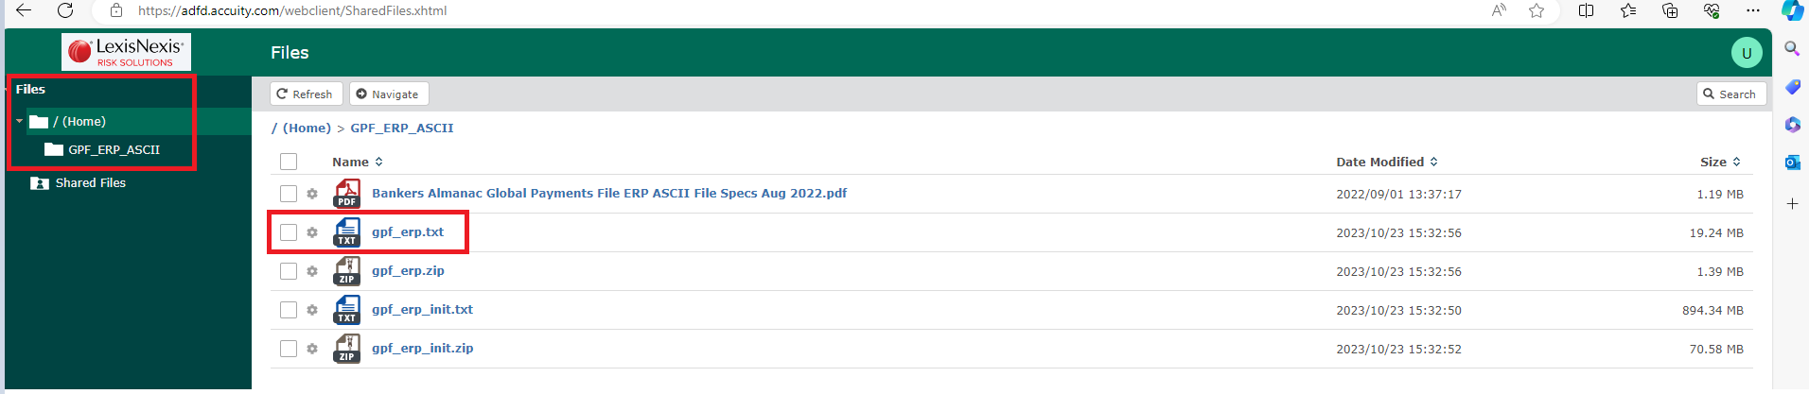

- Open the downloaded grf_erp file in Excel.
- Filter column M by ‘Kingdom’. **In November this changed to column N**
- Copy filtered data into new worksheet.
- Delete columns B and C

The below sections 9 – 11 were not required in the November file. This is because what is now column B contained the full bank name details.

- Insert a new column before what is now column B. Merge columns C and D by entering this simple sum in the first cell of column B =C1&D1.
- Then copy the formula down through the full column B, to do this select the cell with the formula and press Ctrl + Shift + Down Arrow to select the entire column. Then press Ctrl + D to fill the formula down.
- Hide columns C and D.

The below is a new addition for the November file

Hide column C

- Merge columns D, E. F and G so that the address is one field. Enter this simple sum in the first cell of column D ‘=E1 & F1 &G1 & H1’. Then copy the formula down through the full column B, to do this select the cell with the formula and press Ctrl + Shift + Down Arrow to select the entire column. Then press Ctrl + D to fill the formula down.

- Hide columns E, F, G, H as now not required.
- Delete columns G, K, L and M **M, N, O, P, Q and S **as not required.
- The sort code (last 6 numbers) contained in new column K M needs to be split out. Highlight column K M, select Data, Text to Columns.
- In step 1 of the Convert Text to Columns Wizard choose Fixed Width and click Next.
- In step 2 within the Data Preview add a divide line before the sort code and then a divide line after the sort code, then click Next.

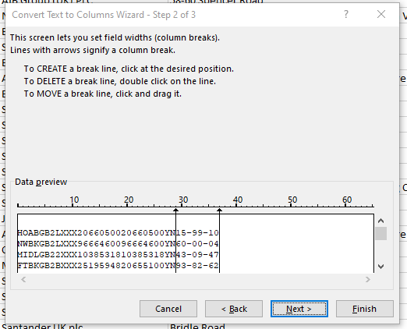

- Click Finish.
- Select ok to replace the data already contained in column L N with the sort code.
- Delete any blank rows from column L as these contain no bank sort codes and are usually duplicate bank detail lines. Highlight column L, click on Data, Filter, filter by blanks. Then delete all the blank rows.
- Refilter to return all the remaining sort code values in column L.
- Remove any dashes included in Column L that divide the sort code. To do this click on Ctrl + H to open the Find and Replace screen, fine – (dash) and replace with blank.
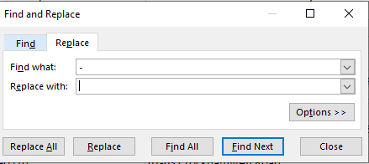

- Review the sort code data in column L. If some data has been interpreted as dates the format of the column will need to be updated. Firsly filter to just look at the date values.
- Select column L, Press F5 on your keyboard to open the Go To dialog box. Click on the Special button and select the Visible cells only option and click OK. This will select the visible cells in the filtered column L.
- Right click on the selected cells and choose Format Cells from the menu. In the format cells screen under the Number tab select custom, then find the current date format that is being displayed in your column L ie dd/mm/yyyy, within the type field update the example from dd/mm/yyyy to ddmmyy, where by the yy is the last two characters of the yyyy. Click OK.

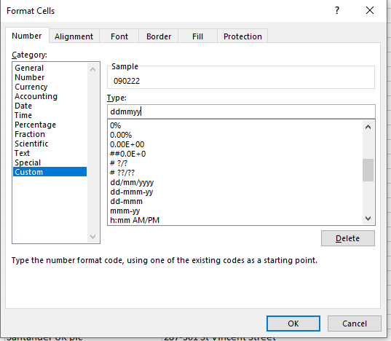

- Review your data in column L. You may notice where a sort code has a leading zero this has been removed, so the format needs to be updated to include this again.
- Highlight column L, right click and select Format Cells. In the format cells screen under the Number tab select custom and in the Type field enter 000000, as in six zero’s for the format. Click OK.

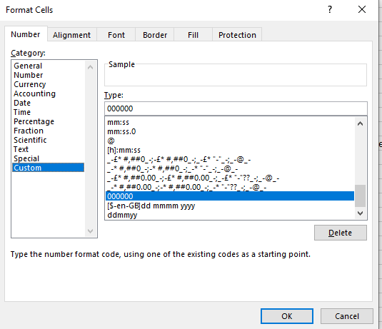

- Next separate the update flag indicator (first letter in column A). Insert a new column between columns A and B. Highlight column A and use the Data, text to Columns, Fixed Width to add a divide after the first letter. This will move the first letter into column A and move the remaining text to column B.

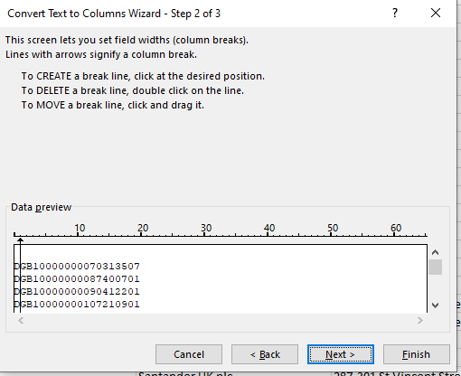

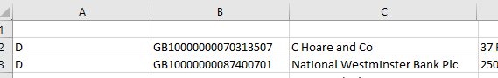

- The update flag indicators are:

D – Deleted record
A – Add or New record
M – Modified record

- Filter column A to only return the update flag indicator of A.

- Next hide the columns not required for the update file. Hide A, B, J, K, L.
Leaving only the remaining fields which are used in the upload:
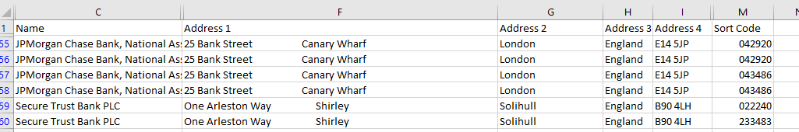

In a new excel worksheet copy the required fields for the upload file in order of: Name, Sort, Address1, Address2, Address3, Address4.

- Now go to Discoverer and run the "PERSUP09_Bank Sort Codes Reference Data" report.

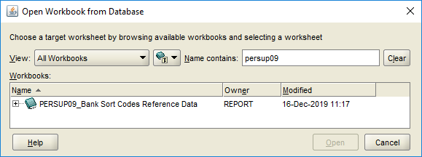

Export the report to Excel.

- In Excel use Conditional Formatting > Highlight Cell Rules > Duplicate Values to compare the sort code listing between PERSUP09 and spreadsheet containing the new bank details.

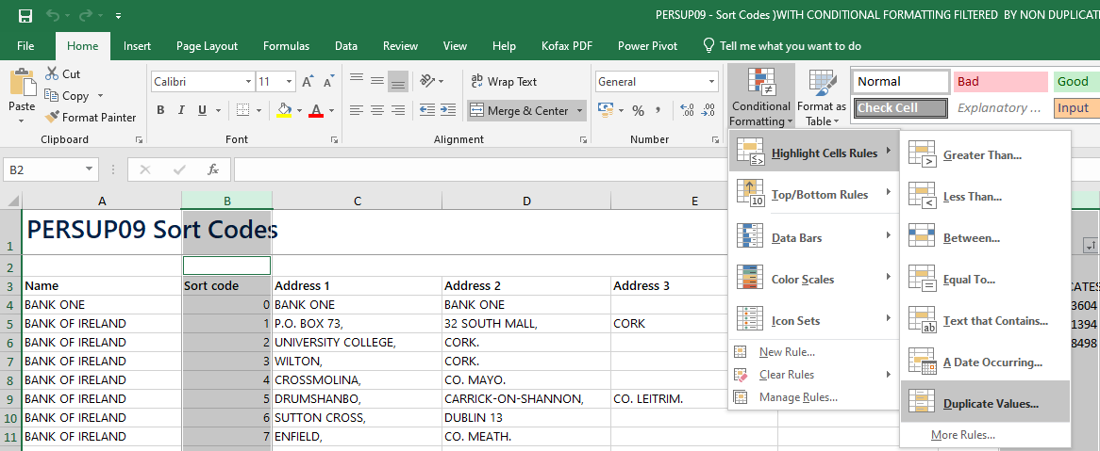

- The non-duplicate sort code bank details can then be moved into the data migration upload file ‘Reference – Bank Reference File’.

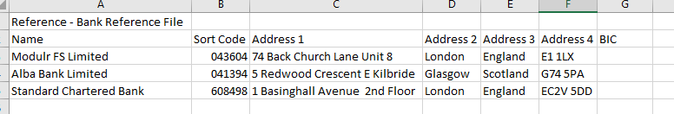

- Ensure the Sort Code is formatted to allow a leading zero. Custom > Type 000000

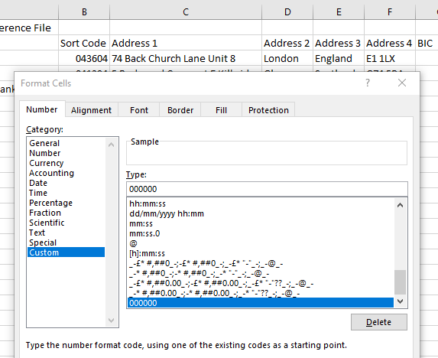

- The file is now ready for upload.

Upload new bank sort codes
Navigate to: CorePortal > Administration Dashboard > Data Migration

- From the Administration Dashboard > Select the Data Migration Tab where the Data Migration Options widget will be available.

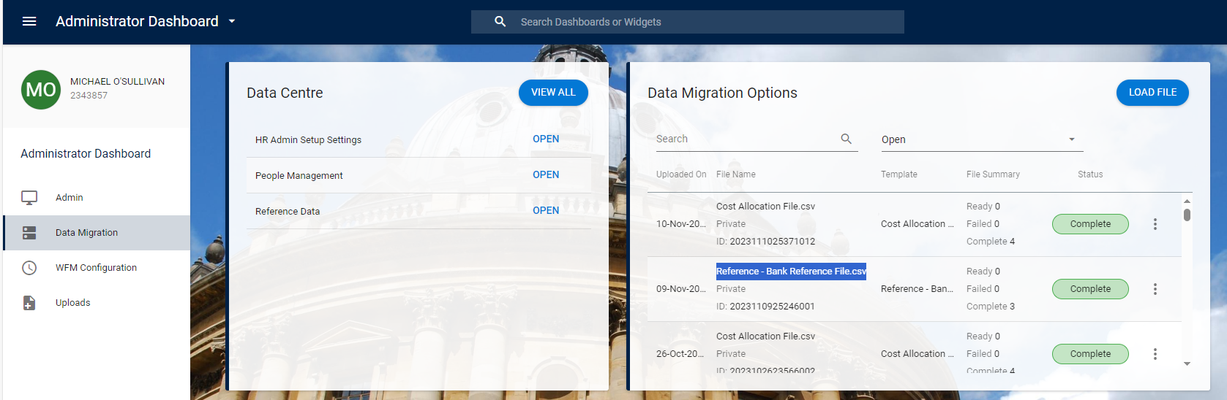

- Within the Data Migration Options widget click on the
Button.

- The Upload screen will open, select the ‘Click or drop file here to upload.



- Locate your file upload file from the File Explorer menu

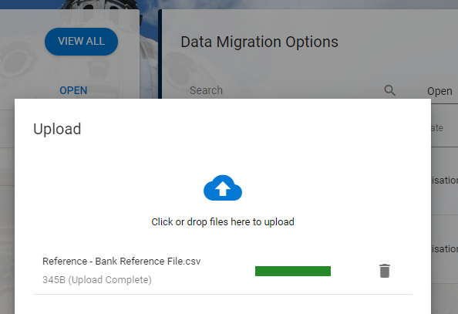

- Click OK. The reference data from the file will be displayed on screen to review.


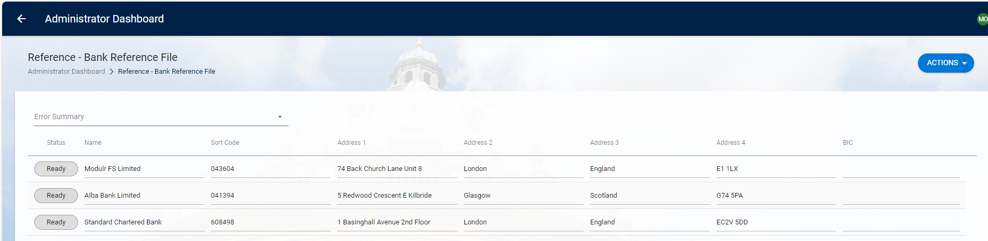

- If all looks correct click on

- You will be returned back to the Data Migration Options screen with the upload file status showing as Processing.

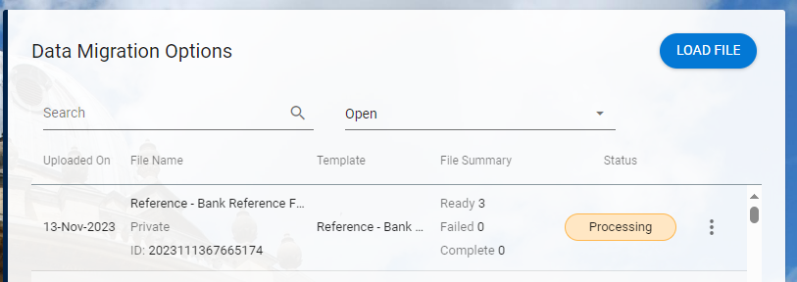

- Once the upload job has completed, if successful the status will update to Completed.

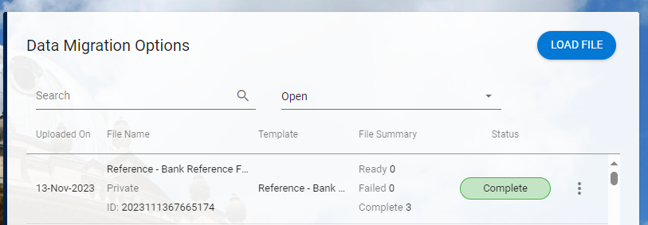

- You should now check the bank details within PeopleXD to ensure these have uploaded as expected.

Check upload data in PeopleXD Payroll Dashboard
Navigate to: Payroll Dashboard > Settings > Bank Details

- When you navigate to the path above, you will be taken to the “Bank Details / Maintain Sort Codes” screen, where the first bank details in the reference library will appear.
- Do a sense-check for some of the banks included in your upload file by clicking the Filter button and search for one of the sort codes in your upload file.

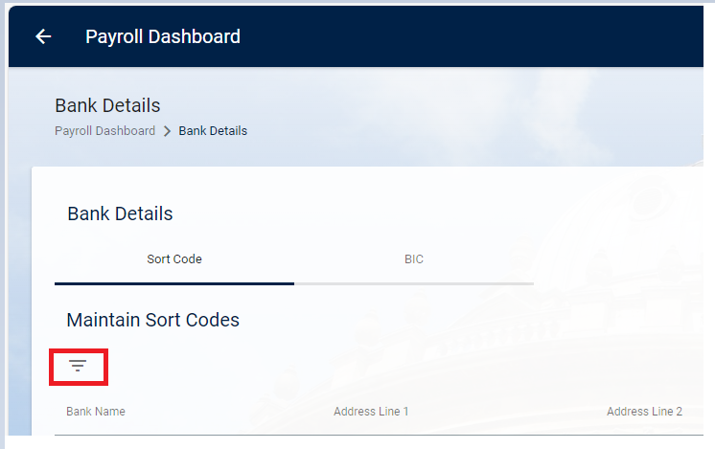

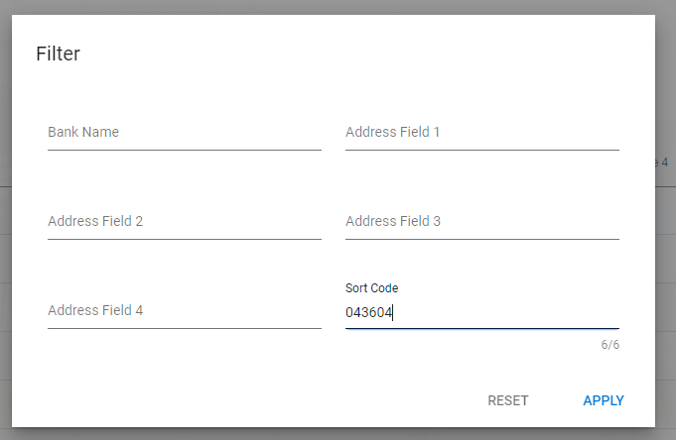

- Click Apply to complete then search. The results will be displayed under the maintain Sort Codes heading.

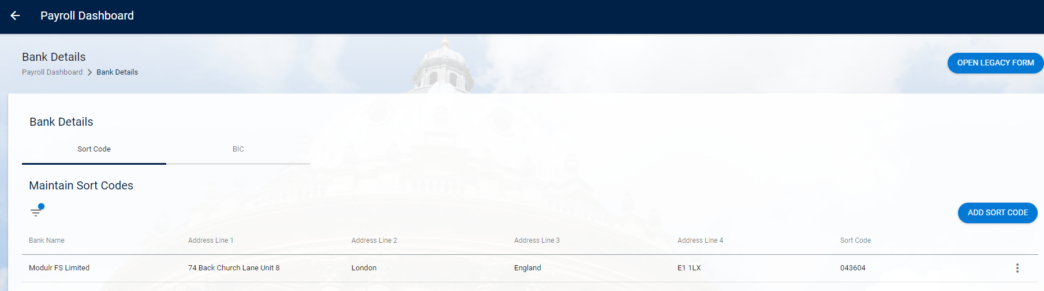

- If the details displayed match the details in your upload file the migration has been successful.

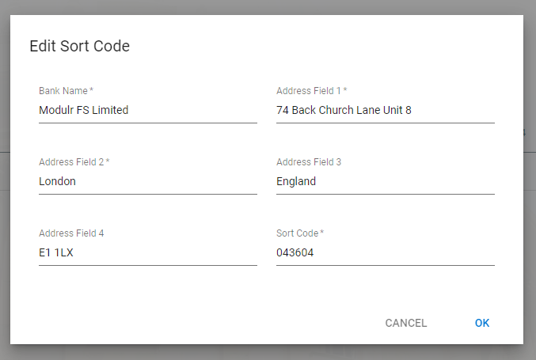

Knowledge Article: P:\PROJECTS\HRIS Programme\12. Support\Change Control\Change Management Knowledge Documents\Bank Sort Codes Knowledge Article.docx

